# CHAPTER 1: INTRODUCTION

## 1.1. Introduction

All students pursuing the Bachelor of Science In Information Technology (BIT) degree at Purbanchal University are required to do a 3-credit internship that must last at least 6 weeks or 45 hours as part of the program's 7th semester. This internship's successful completion is a prerequisite for the course.

An internship is a brief period of employment provided by businesses and other organizations to individuals—typically students, but not always—who wish to get some introductory experience in a specific area or profession. It is both labor and a learning experience in equal measure. (Zhang, 2020) An internship serves as a structured opportunity for students to gain practical experience aligned with their academic and career aspirations. This experience aims to enhance students' personal and professional growth by offering exposure to real-world scenarios closely related to their major. Typically lasting three to four months, interns engage in direct personal interactions or training programs to further their understanding and skills. This specific internship program, in line with Purbanchal University's curriculum for the Bachelor's in Science and Information Technology, provides a platform for students to apply their theoretical knowledge in a corporate setting. Through this program, students not only gain insights into company operations but also witness the practical implementation of subjects studied during their BIT course. From Data Structure and Algorithm to Web Technology, each subject's application is vividly experienced, fostering skill development and familiarity with professional environments. This internship initiative effectively introduces students to organizational structures and the professional realm.

## 1.2. Introduction to the Project

Rental Marketplace , Product And Service Management System is an innovative web application developed during my internship at Need Technosoft Pvt. Ltd., designed to revolutionize the rental marketplace ecosystem in Nepal. The platform serves as a centralized system for managing rental products, connecting users with available items across various categories. With a focus on providing seamless access to rental products, Rental Marketplace functions as a user-friendly platform that empowers users to effortlessly explore, discover, and secure rentals for an array of products.

This versatile platform is tailored to meet the diverse rental needs of users across Nepal. Through Rental Marketplace , Product And Service Management System users can access comprehensive information on product details, availability, and pricing, enabling them to make informed decisions about their rental choices. The application's intuitive interface and robust filtering capabilities ensure a user-centric experience that simplifies the process of discovering and booking rental items.

## 1.3. Problem Statement

The current service market in Nepal lacks an efficient and user-centric platform for accessing and managing rental products, event tickets, and various other services. Existing methods often involve using multiple fragmented platforms, resulting in limited visibility of available offerings and insufficient information for consumer decision-making. The need for a streamlined and unified platform that bridges the gap between service providers and consumers, while also offering detailed information and easy booking options across different service categories, is evident.

• Limited accessibility to rental products,Tickets, and services in Nepal due to fragmented traditional systems.

• Lack of a centralized platform for discovering and booking various offerings.

• Absence of comprehensive filtering options based on service types, categories, locations, and price ranges.

• Disconnect between service providers and potential consumers, hindering seamless interaction. • Inconvenience in exploring options and comparing prices across different service categories.

• Inefficient e-ticketing solutions for events, causing difficulties in ticket acquisition and management.

## 1.4. Objectives

The objectives of this internship are as follows:

• Develop a fully functional multi-service platform using Laravel that integrates rental marketplace, e-ticketing, and additional service offerings.

• Implement an admin-user architecture that enables efficient management of all system components.

• Create an intuitive filtering system based on service types, categories, locations, and price ranges.

• Design and develop a responsive user interface for optimal user experience across devices.

• Implement a secure e-ticketing system with features for browsing, purchasing, and managing event tickets.

• Integrate additional service offerings beyond rentals and ticketing to create a comprehensive marketplace.

• Gain practical experience in applying theoretical knowledge to real-world projects.

• Enhance skills in web development, focusing on practical applications and problem-solving.

• Acquire insights into industry practices, team collaboration, and project management.

• Develop effective communication skills through interactions with colleagues and mentors.

• Produce a comprehensive internship report that summarizes the experiences and lessons learned.

## 1.5. Scope and Limitation

1.5.1. Scope• Product Management System: The platform incorporates a comprehensive system for managing rental products, including categorization, pricing, and availability tracking.

• E-Ticketing System: Implementation of event discovery, ticket purchasing, and digital ticket management functionalities.

• Additional Service Integration: Incorporation of various service offerings beyond rentals and ticketing to create a comprehensive marketplace.

• User Management: Implementation of user registration, authentication, and profile management functionalities.

• Admin Dashboard: Development of an administrative interface for managing products, tickets, services, users, and overall system operations.

• Search and Filter Functionality: Implementation of robust search and filtering capabilities across all service types based on multiple parameters.

• Practical Application: The internship provides the opportunity to apply academic theory to real-world tasks in developing a functional multi-service platform.

• Enhancement of Skills: Working in a professional setting to gain valuable skills in web development using Laravel, database design, UI/UX implementation, and problem-solving.

• Industry Insights: Gaining knowledge about industry methods, technologies, and workflows to better understand current trends and best practices in web application development.

• Professional Network: Forming crucial connections with experienced professionals that may benefit future career opportunities.

### 1.5.2. Limitation

• Time Restrictions: Due to the internship's limited duration, it may not be possible to implement all desired features or optimizations across all service categories.

• Learning Curve: Adaptation time required to become familiar with the Laravel framework, company-specific development practices, and tools used in the project.

• Contribution Scope: The transient nature of the internship may limit participation in long-term development or maintenance of the platform.

• Exposure Variability: The breadth of experiences and tasks may vary depending on the specific requirements and priorities of the Rental Marketplace project during the internship period.

• Limited Integration Options: The platform may have constraints regarding integration with third-party services for payment processing, mapping, or other advanced functionalities. • Scale Limitations: The system may be designed for initial deployment rather than handling large-scale user bases or service inventories.

• Security Considerations: Given the inclusion of e-ticketing and potentially financial transactions, implementing robust security measures within the internship timeframe presents challenges.

## 1.6. Report Organization

**Chapter One: Introduction**

The issue description, objectives, scope, and limitations of our project are all included in the first chapter's introduction.

**Chapter Two: Organizations Details**

The introduction to the organization, its hierarchy, and its working domain are all included in this chapter.

**Chapter Three: Internship Activities**

Roles and duties, a weekly record, and a description of the project engaged during the internship are all included in this chapter.

**Chapter Four: Conclusion and Learning Outcomes**

The system's conclusion and the lessons learned through the internship are both included in this chapter.

**Reference**

All references are included in APA style at the conclusion.

# CHAPTER 2: ORGANIZATION DETAILS AND LITERATURE REVIEW

## 2.1. Introduction to Organization

The respected IT business Need Technosoft, based in Biratnagar, is well known for its outstanding software solutions. Need Technosoft has been a leader in bringing cutting-edge technical developments to several sectors since its founding. The business has made a name for itself in the IT industry by firmly committing to innovation and quality. Need Technosoft's dynamic team of specialists consistently aims to offer customized and significant solutions to its clients. The business is a major player in Biratnagar's IT industry because of its commitment to keeping on the cutting edge of technology and its track record of successful projects.

The logo of the company, Need Technosoft Pvt. is shown below:



**Figure 1: Logo of the Company**

The location of the company, Need Technosoft Pvt. Ltd. in Google Maps is shown below:

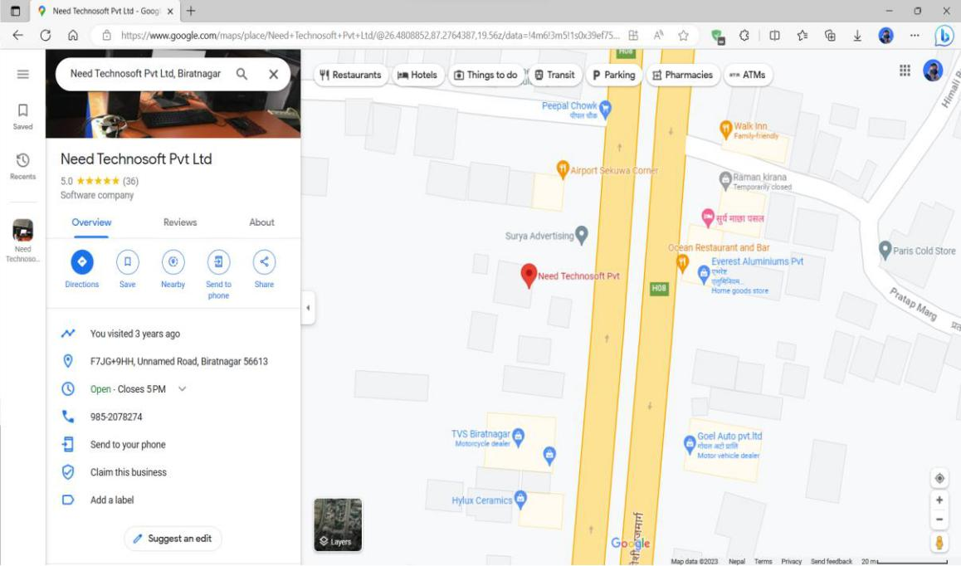

**Figure 2: Location of Need Technosoft Pvt. Ltd. in Google Maps**

**Company Summary**

**Table 1: Table of Company Detail**

|  |  |
| --- | --- |
| **Company Name** | **Need Technosoft Pvt. Ltd.** |
|  |  |
| **Contact Number** | +977-9800916365 |
|  |  |
| **Email Address** | info@needtechnosoft.com.np |
|  |  |
| **Website** | [needtechnosoft.com.np](https://www.needtechnosoft.com.np/) |
|  |  |
| **Address** | Biratnagar-3, Morang, Koshi Province, Nepal |
|  |  |

6

## 2.2. Organizational Hierarchy

The organizational hierarchy of Need Technosoft is as below:

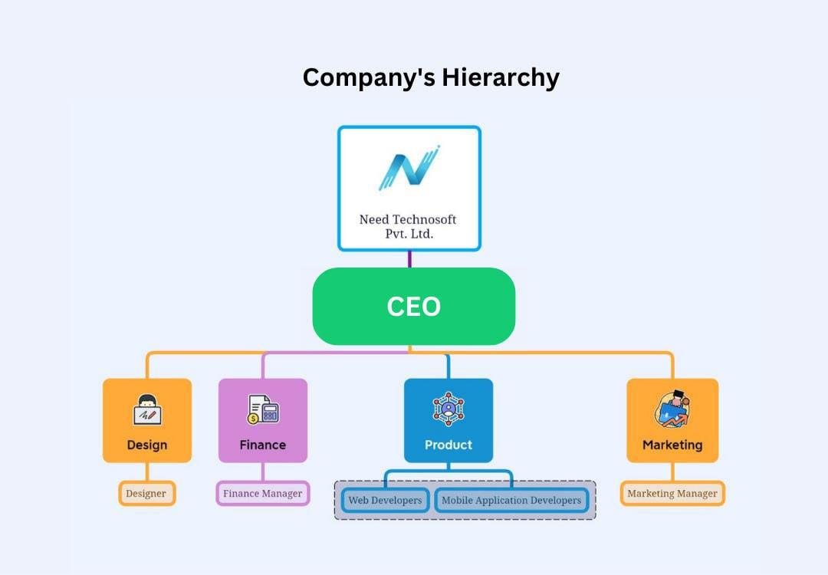

**Figure 3: Organizational Hierarchy of Need Technosoft**

## 2.3. Working Domains of Organization

Need Technosoft Pvt. Ltd. is active in a wide array of industries, spanning various sectors. Committed to excellence, Need Technosoft meticulously caters to the specific demands of each industry it engages with, consistently delivering tailored and effective solutions that drive its clients toward success. Some of the domains that the organization touches are as follow:

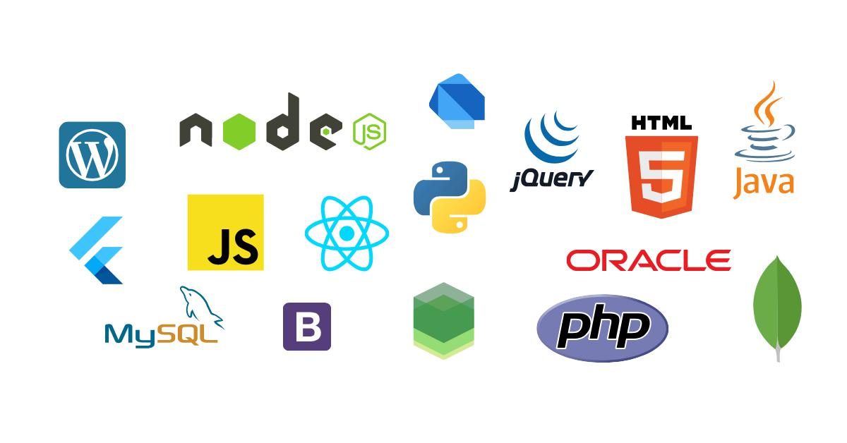

**Figure 3: Working Domains of Need Technosoft**

## 2.4. Description of Intern Department

I recently finished a 6-week internship at Need Technosoft Pvt. Ltd., where I actively participated in a variety of organizational tasks. The table that follows details the duration of my internship at the firm.

**Duration of Internship**

The organization's standards include that the internship term for this project must run a minimum of 6 weeks, or 100 hours. The selection of an appropriate company is crucial to the internship program's success. I worked as an intern and a contributing member of the organization for a total of four months throughout this internship. When a carefully picked company provides more exposure to the real-world workplace, the primary objective of the internship endeavor is realized.

Following are the details of the duration of my internship period.

**Table 2: Table of Internship Duration Details**

|  |  |
| --- | --- |
| Start Date of the Internship | 22st May, 2023 |
|  |  |
| End Date of the Internship | 4th August, 2023 |
|  |  |
| Total Duration | 10 weeks |
|  |  |
| Office Hour | 10 A.M. – 6 P.M. |
|  |  |
| Office Days | Sunday – Friday |
|  |  |
| Holiday | Saturday/National Holiday |
|  |  |

# CHAPTER 3: INTERNSHIP ACTIVITIES

## 3.1. Roles and Responsibilities

During my internship at Need Technosoft, my role as a Web Developer was dedicated to developing a comprehensive Rental Marketplace, E-Ticketing, and Multi-Service Management System called Rental Marketplace. Throughout the internship, my responsibilities were thoughtfully tailored to align with my skillset and learning objectives under the guidance of a committed mentor. I actively engaged in various web development activities, with a primary focus on crafting and refining user interfaces and implementing core functionalities for the Rental Marketplace platform.

My primary focus was on Web Application Development, where I played a pivotal role in transforming conceptual ideas into a fully operational and user-friendly multi-service platform. Leveraging my expertise, I led the development of the Rental Marketplace web app using appropriate web technologies, primarily the Laravel framework along with front-end technologies such as HTML, CSS, and JavaScript.

Another important duty I performed was feature implementation. This involved converting several application capabilities, such as the product filtering system, user and admin interfaces, and service management modules, into functional and user-centric elements that improved the Rental Marketplace platform's overall user experience. I implemented core features including product categorization, search functionality, and the admin dashboard for managing various aspects of the system.

I gained practical experience in web app development, database management, and feature implementation during my internship at Need Technosoft as a Web Developer. These experiences greatly aided the development of the Rental Marketplace ,Product and Service Management System and enhanced my web development expertise, particularly in building complex multi-service platforms.

## 3.2. Weekly Log

The summary of 10 weeks internship period is listed below:

The detailed Weekly Log of the 6-week internship period is in the Appendix section of this report.

|  |  |
| --- | --- |
| **Week No.** | **Responsibilities** |
| Week 1 | Introduction to company structure, culture, and working domains - Internship plan preparation - Project discussion (Rental Marketplace) - Project planning and goal setting for the internship |
| Week 2 | Learning basics of Laravel, PHP, and related development tools - Exploring useful packages and extensions - Attending training classes for programming improvement - Collaborating with the team to understand development procedures |
| Week 3 | Setting up the Laravel project structure - Designing the database schema for the rental marketplace and e-ticketing system - Creating initial models for products, services, and users - Implementing basic routing and controller structure |
| Week 4 | Developing the user authentication system - Creating admin and user roles with appropriate permissions - Implementing user profile management - Starting development of the product management module |
| Week 5 | Completing the product management system with CRUD operations - Implementing the product filtering functionality based on categories, locations, and price ranges - Developing the initial UI components for the product listing and details pages |
| Week 6 | Implementing advanced search functionality across all service types - Integrating different service modules into a cohesive platform - Conducting comprehensive testing and bug fixing - Preparing final documentation and deployment preparations |

## 3.3 Description of Project Involved

The Rental Marketplace project, to which I contributed as a Web Developer intern at Need Technosoft, is a dynamic and innovative endeavor aimed at revolutionizing the way users in Nepal access rental products, event tickets, and various services through a unified platform. Developed with a user-centric approach, the Rental Marketplace web application offers a seamless and user-friendly interface that empowers users to effortlessly explore, discover, and secure rentals, tickets, and additional services for a diverse range of needs.

As a Web Developer intern, my involvement in the Rental Marketplace project focused on developing both frontend and backend components of the web application. This encompassed translating conceptual ideas into tangible user interfaces and functional systems that catered to the needs and preferences of the users. Leveraging Laravel framework and associated web development technologies, I played a key role in crafting visually appealing and responsive components that ensured an engaging and efficient user experience.

Collaboration was a significant aspect of my role, as I closely worked with senior developers and designers to create a cohesive and efficient system. This collaborative effort aimed at building a versatile platform that could seamlessly handle multiple service types while maintaining a consistent and intuitive user interface across all modules.

**Technological Stack Used:**

Laravel Framework: A robust PHP framework that provides the foundation for the application, offering features like routing, middleware, and MVC architecture. Laravel's elegant syntax and comprehensive ecosystem made it an ideal choice for building a complex multi-service platform.

PHP: The primary server-side programming language used in combination with Laravel to implement backend logic, data processing, and application functionality.

MySQL: A reliable relational database management system used to store and retrieve all application data, including product information, user details, booking records, and service specifications.

HTML/CSS: Standard web technologies used for structuring the content and styling the appearance of the application's user interface, ensuring a visually appealing presentation.

JavaScript/jQuery: Used to implement dynamic and interactive elements on the client-side, enhancing the user experience with real-time feedback and seamless interactions.

Bootstrap: A CSS framework that provided responsive layout components and pre-styled elements, accelerating the development of a mobile-friendly interface.

AJAX: Implemented to enable asynchronous data loading, particularly in the product filtering system, allowing users to refine search results without page reloads.

Git: Version control system used to track changes, manage code versions, and facilitate collaboration within the development team.

Laravel Blade: The templating engine used to create dynamic and reusable view components, enhancing development efficiency and code organization.

Laravel Eloquent ORM: Used for database interaction, providing an intuitive and expressive interface for database operations without writing raw SQL queries.

## 3.4. Tasks / Activities Performed

During my internship at Need Technosoft Pvt. Ltd., I had the opportunity to work with Laravel while contributing to the development of the Rental Marketplace web application. Under the guidance of my mentor, I carried out various duties and activities that enhanced my Web Development skills and advanced the project.

I became familiar with the setup and configuration procedures for key development tools including Visual Studio Code, XAMPP, Composer, and Laravel. Additionally, I gained practical experience with the Laravel ecosystem, which served as the foundation for the Rental Marketplace web application.

In conclusion, the Web Development internship at Need Technosoft provided me with valuable hands-on experience using Laravel for the development of the Rental Marketplace multi-service platform. The tasks and activities I undertook not only improved my technical proficiency but also gave me the opportunity to make a significant contribution to the development of a user-centered and functional web application.

Activities:

• Frontend Development:

Designing and implementing user interfaces (UI) for the web application

Creating responsive web pages using HTML, CSS, and JavaScript

Developing interactive features for user interactions

Implementing the product filtering system with dynamic search capabilities

• Backend Development:

Building server-side logic using Laravel controllers and services

Setting up routes to handle data requests from the frontend

Implementing user authentication and authorization with role-based permissions

Creating middleware for access control and request validation

• Database Management:

Designing and creating the database schema with relationships

Writing Eloquent queries to retrieve and store data

Implementing database migrations for schema version control

Creating seeders for testing and initial data population

• Integration of Payment Gateways:

Researching payment gateway options suitable for the Nepalese market

Implementing payment processing for rental bookings and ticket purchases

• User Authentication and Authorization:

Implementing user registration and login systems

Creating separate user and admin dashboards

Managing user roles and permissions for accessing different features and services

• Performance Optimization:

Identifying and resolving performance bottlenecks in the application

Implementing caching mechanisms to improve load times

Optimizing database queries for better response times

• Testing and Quality Assurance:

Writing and executing tests for critical application components

Conducting user acceptance testing to ensure functionality aligns with requirements

Performing cross-browser testing for compatibility

• Documentation:

Creating documentation for code, APIs, and project setup

Preparing user guides for both admin and end-user interfaces

Contributing to the project knowledge base for future reference

• Collaboration:

Collaborating with team members, including designers and other developers

Participating in regular team meetings to discuss progress and address issues

• Bug Fixing and Maintenance:

Identifying and resolving bugs or issues reported during testing

Implementing improvements based on user feedback

Refactoring code for better maintainability and scalability

# **C**HAPTER 4: CONCLUSION AND LEARNING OUTCOMES

## 4.1. Conclusion

In conclusion, my time as a Web Developer intern at Need Technosoft working on the Rental Marketplace project has been a rewarding experience that has significantly enhanced my progress and skill in web development. The Rental Marketplace platform aims to revolutionize how people access and interact with rental products, event tickets, and various services through a unified interface. It embodies innovation, user-centric design, and seamless functionality. During my internship, I had the honor of actively helping to develop both frontend and backend components of the system, where I implemented intuitive user interfaces and integrated essential functionalities across multiple service modules.

My involvement in the Rental Marketplace project allowed me to translate theoretical knowledge into practical expertise, as I navigated through the intricacies of web development using Laravel, database management, and collaborative teamwork. By working with senior developers and designers, I gained valuable insights into building complex multi-service platforms, contributing to the application's overall performance and user experience. The development of features like the product filtering system, admin dashboard, and service integration provided me with hands-on experience in creating solutions that address real-world user needs.

The completion of this internship marks not just the successful implementation of a comprehensive rental marketplace and multi-service management system, but also represents a significant milestone in my professional development as a web developer. The skills and knowledge gained through this experience have equipped me with a strong foundation for future endeavors in the field of web application development.

## 4.2. Learning Outcomes

The scope of learning outcomes achieved through the Rental Marketplace project and my internship in web development is substantial. This journey has not only deepened my technical skills but has also enriched my overall professional growth and adaptability within the industry. The following learning outcomes reflect the valuable knowledge acquired:

Technical Mastery: My expertise in web development has significantly expanded, thanks to hands-on experience and guidance. I've gained comprehensive proficiency in working with the Laravel framework, PHP programming, database management with MySQL, frontend technologies (HTML, CSS, JavaScript) .

Practical Application: This project has bridged the gap between theoretical knowledge and practical application, illuminating the intricacies of developing user-centric web applications and shedding light on the challenges that come with building multi-service platforms. I learned to implement complex features like product filtering systems, user authentication with role-based permissions, and integration of diverse service modules into a cohesive platform.

Collaborative Aptitude: Navigating a dynamic team environment has enhanced my collaborative skills, enabling seamless task delegation, effective idea exchange, and active participation in group endeavors. Working with designers, senior developers, and project managers taught me the importance of clear communication and coordinated efforts in delivering successful web applications.

Problem-Solving Agility: Tackling real-time development hurdles and debugging issues has sharpened my problem-solving acumen. It has inspired me to explore innovative solutions and troubleshoot efficiently across various components of the system, from database optimization to frontend responsiveness.

Database Design and Management: Designing and implementing a database structure capable of supporting multiple service types while maintaining data integrity and efficiency was a valuable learning experience. I gained skills in creating relationships between different data entities and optimizing database queries for better performance.

System Architecture Understanding: Working on a comprehensive platform provided insights into how different components interact within a larger system. I learned about modular design principles, separation of concerns, and how to structure code for maintainability and scalability.

Project Management Exposure: By participating in the development lifecycle from planning to deployment, I gained appreciation for project management methodologies, timeline estimation, and resource allocation in web development projects.

Security Implementation: Implementing user authentication, authorization controls, and data protection measures enhanced my understanding of web application security principles and best practices for protecting sensitive user information.

Client-Centric Development: The process of translating client requirements into functional features taught me the importance of maintaining focus on end-user needs while balancing technical constraints and project timelines.

Documentation Skills: Creating technical documentation and user guides improved my ability to communicate complex concepts clearly and provide valuable resources for both technical and non-technical stakeholders.

These learning outcomes have significantly contributed to my professional development and have prepared me for future challenges in web development. The practical experience gained through developing the Rental Marketplace platform has equipped me with a diverse skill set that extends beyond technical knowledge to include soft skills essential for success in the industry.

**REFERENCES**

1. Akhtar, S. (2021, May 18). Laravel: The PHP Framework for Web Artisans. Retrieved from Geeksforgeeks
2. Amini, M. (2022, February 12). Building a Multi-Service Platform with Laravel. Retrieved from Laravel News
3. Bean, M. (2021, April 4). MySQL for Laravel Developers: Best Practices and Optimization Techniques. Retrieved from DigitalOcean Community:
4. Gupta, R. (2022, June 15). Creating Effective Filtering Systems in Laravel Applications. Retrieved from Medium
5. Jain, P. (2021, November 8). Understanding Laravel's Eloquent ORM for Database Management. Retrieved from Geeksforgeeks
6. Kumar, A. (2022, March 5). E-ticketing Systems: Design Patterns and Implementation Strategies. Retrieved from TechStack
7. Mehta, K. (2021, July 12). Role-Based Authentication Systems in Laravel. Retrieved from Laravel Daily
8. Patel, N. (2022, April 29). Building Rental Marketplace Platforms: Challenges and Solutions. Retrieved from LogRocket
9. Sharma, V. (2021, August 18). Modern UI Design Principles for Web Applications. Retrieved from UXPlanet
10. Smith, J. (2022, January 9). The Evolution of Online Marketplace Systems. Retrieved from Smashing Magazine
11. Taylor, O. (2022, February 23). Essential Laravel Packages for Rapid Application Development. Retrieved from Laravel News
12. Thompson, D. (2021, October 2). Responsive Design Techniques for Modern Web Applications. Retrieved from CSS-Tricks

**Screenshots**

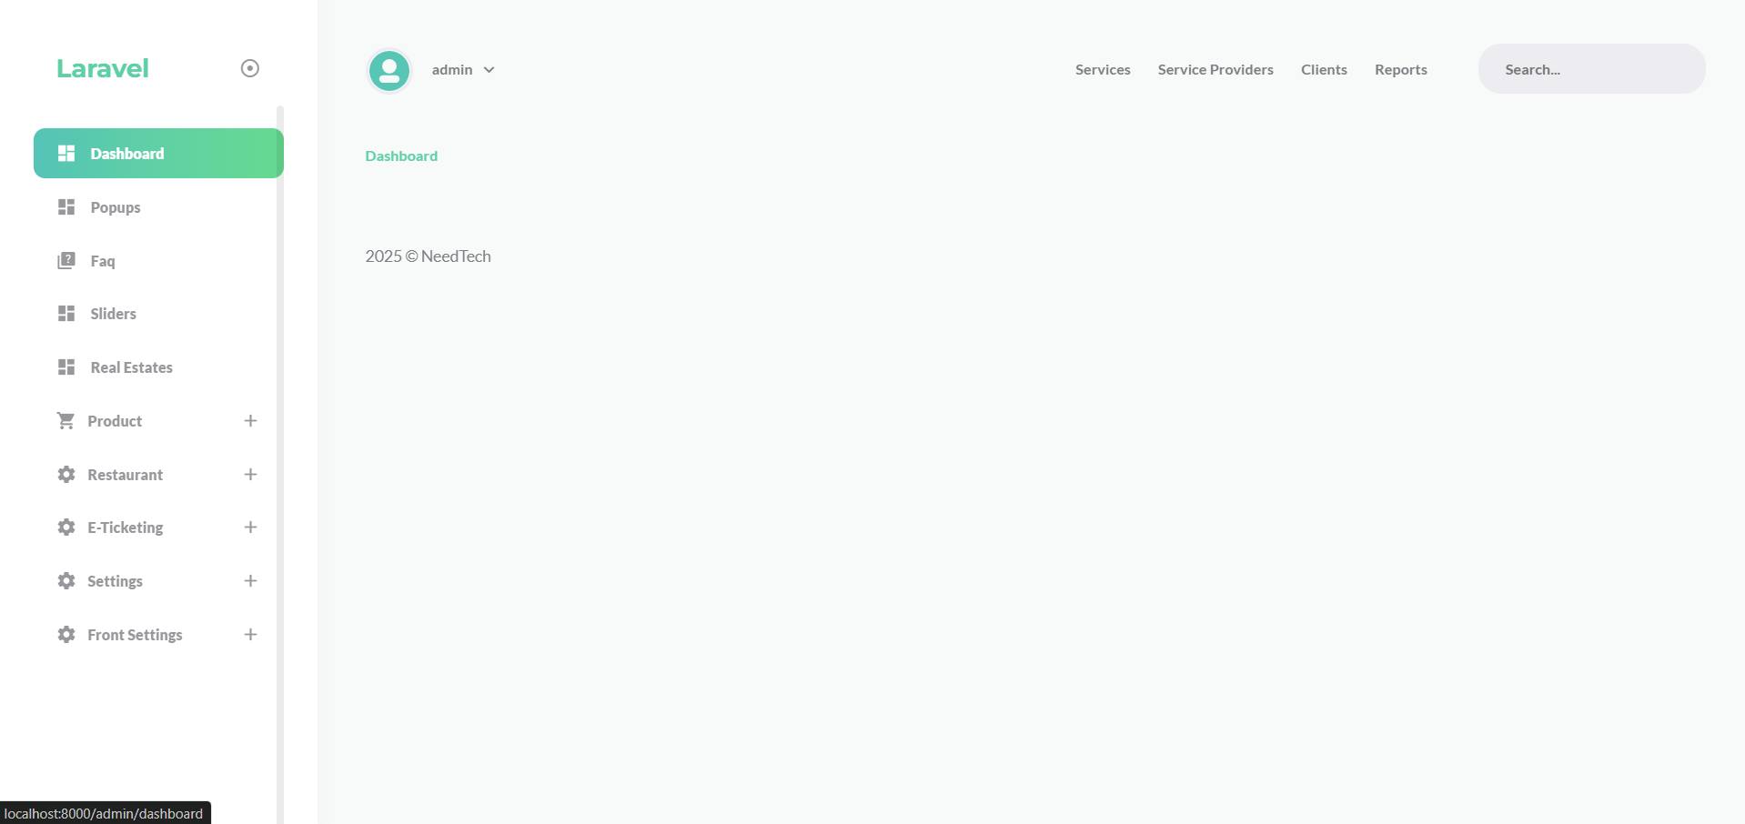

**Fig 1 : Admin Dashboard**

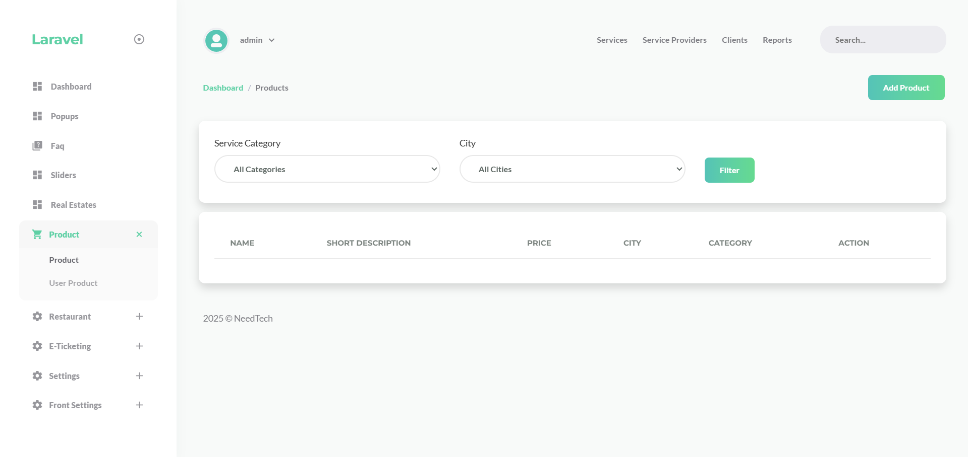

**FIg 2 : Product Page**

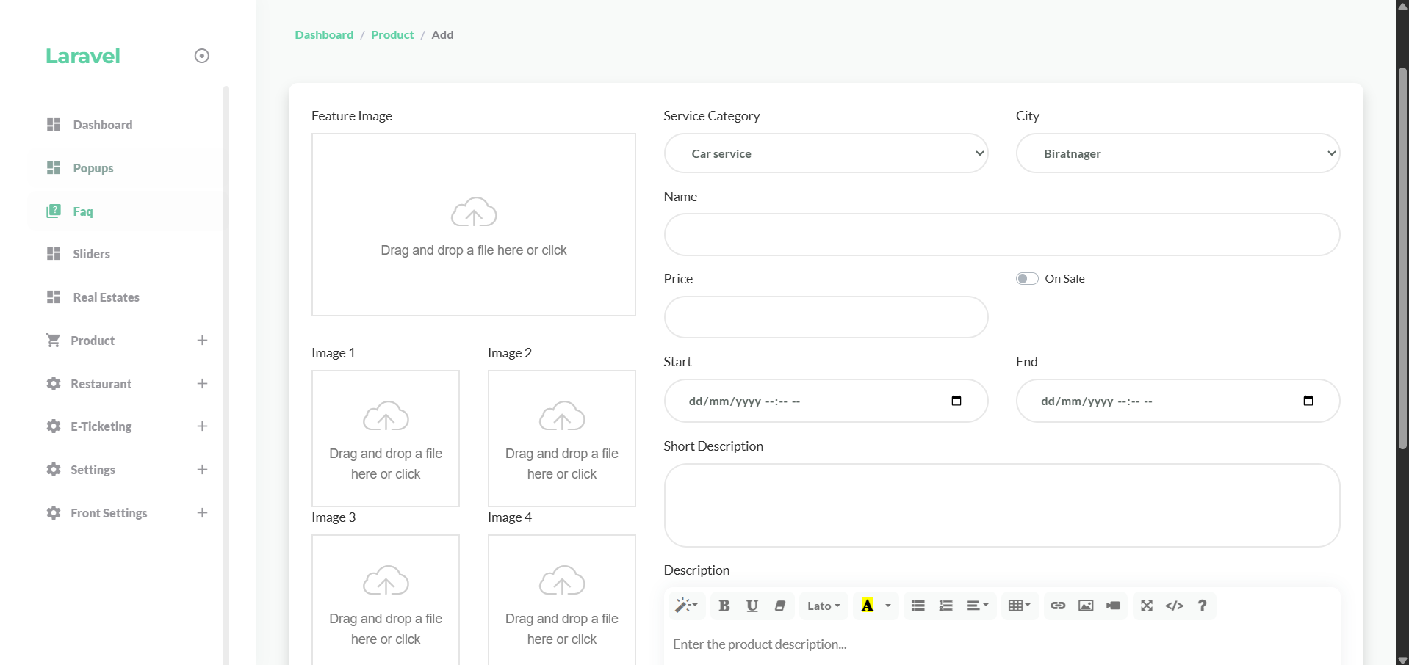

**FIG 3 : Admin Product Adder Page**

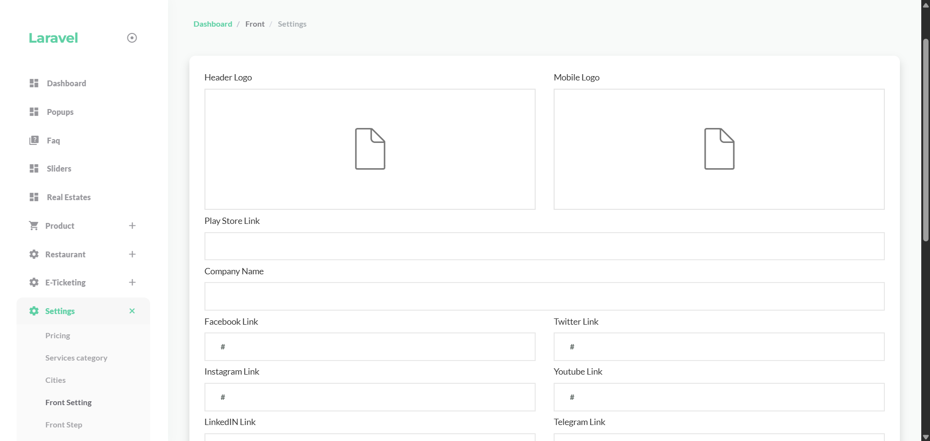

**Fig 4 : Front Page Setting**

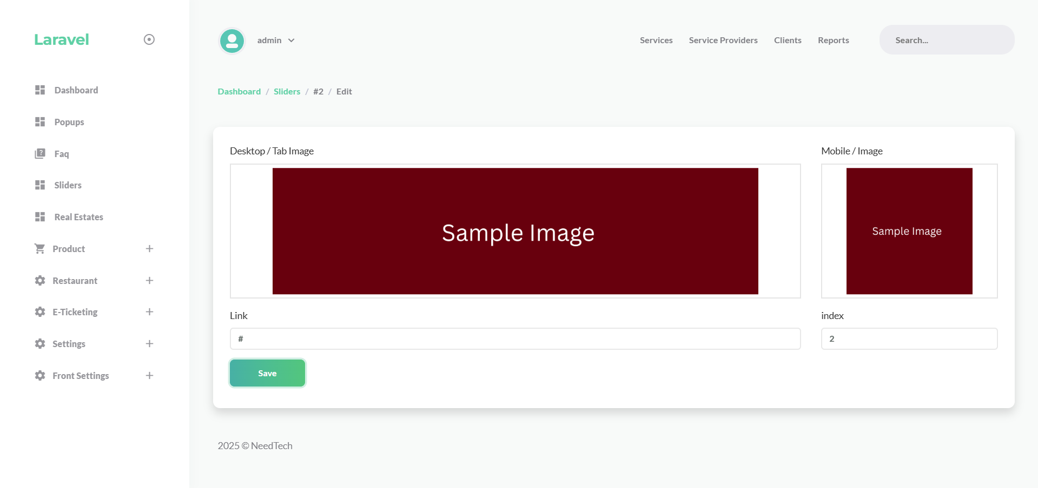

**Fig 5 : Front slider adder Page**

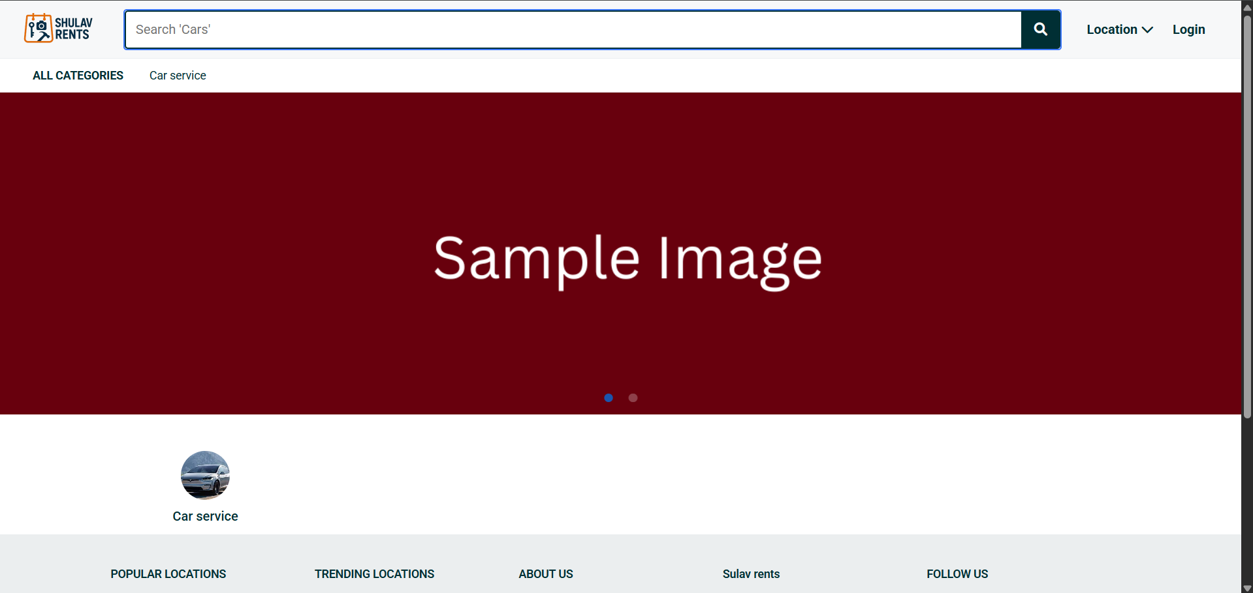

**Fig 6 : Front Page**

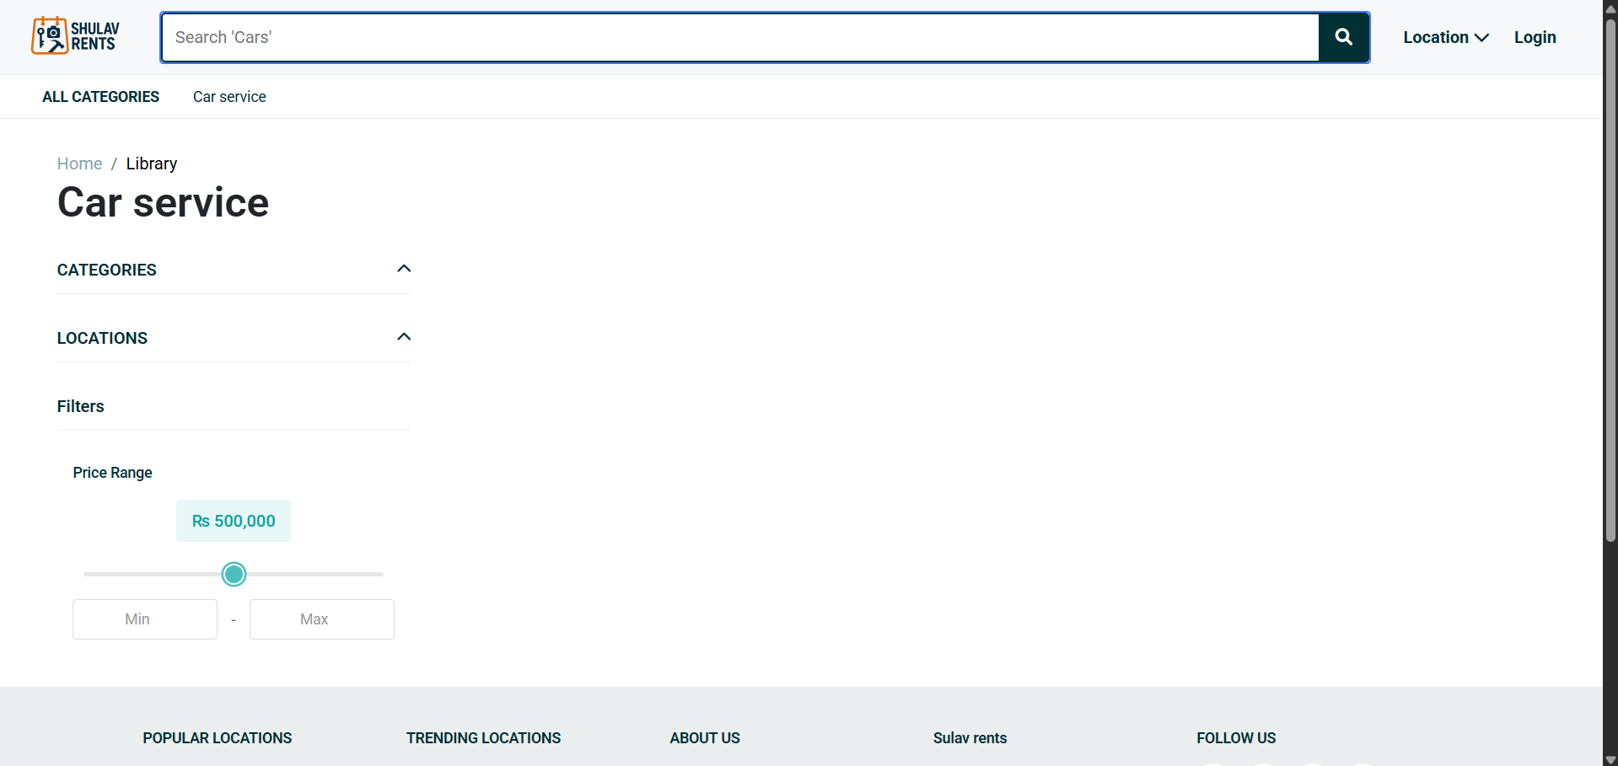

**Fig 7 : Front Single Service Type Page**

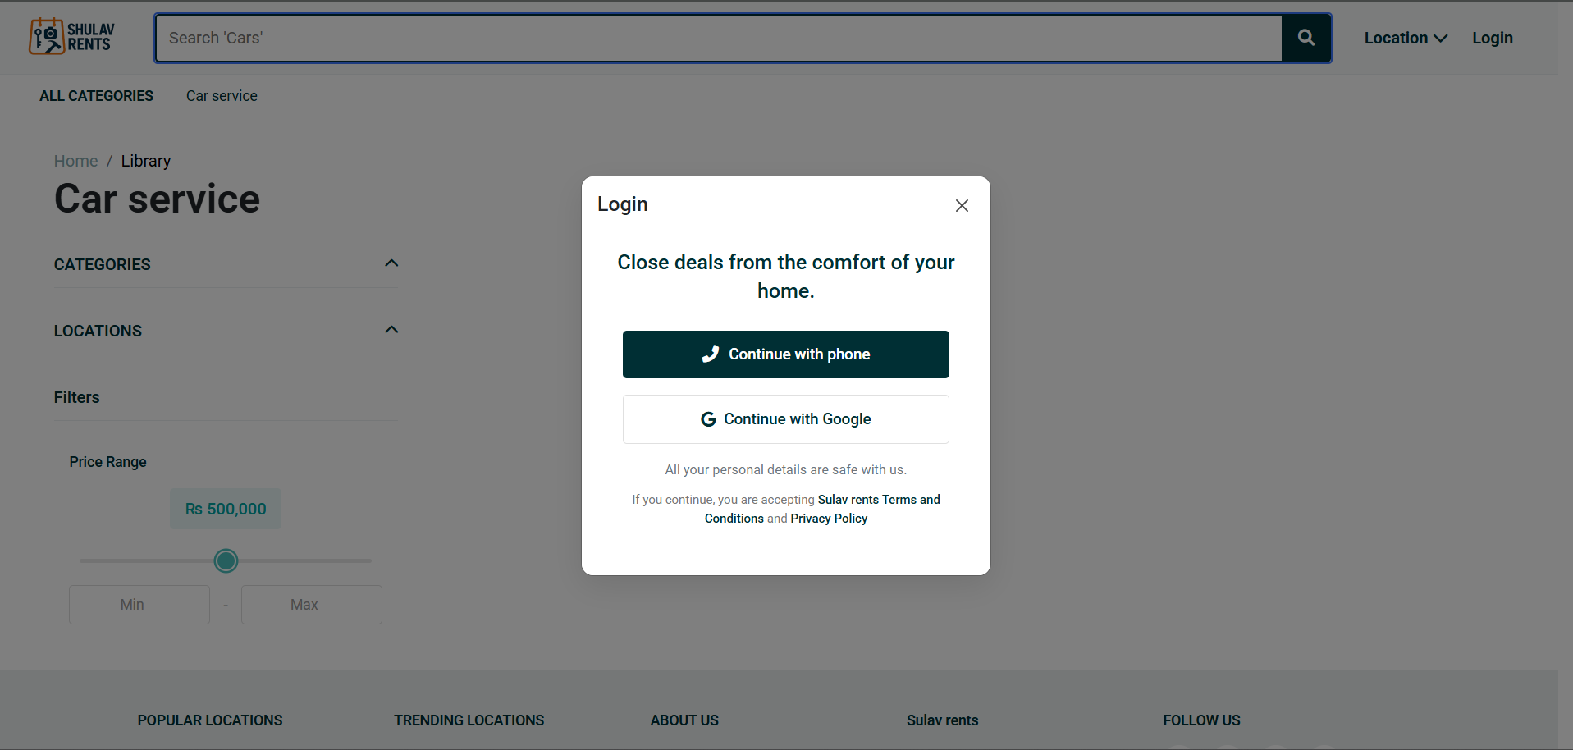

**Fig 8 : Front User Login**

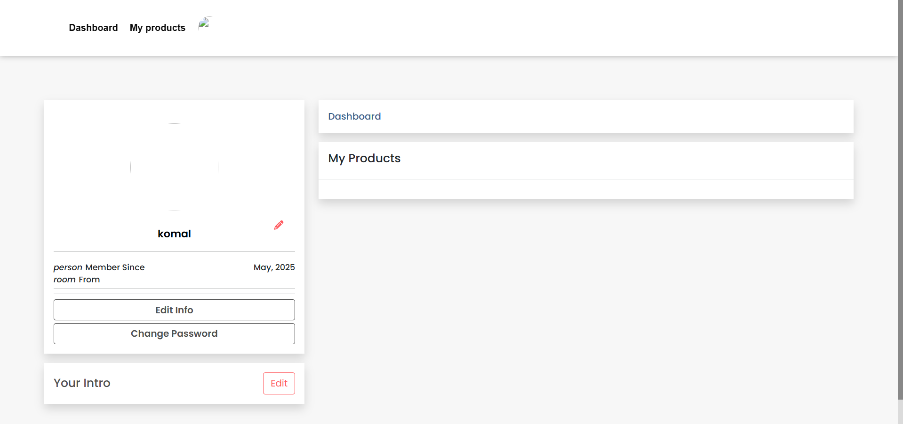

**Fig 9 : User Page**

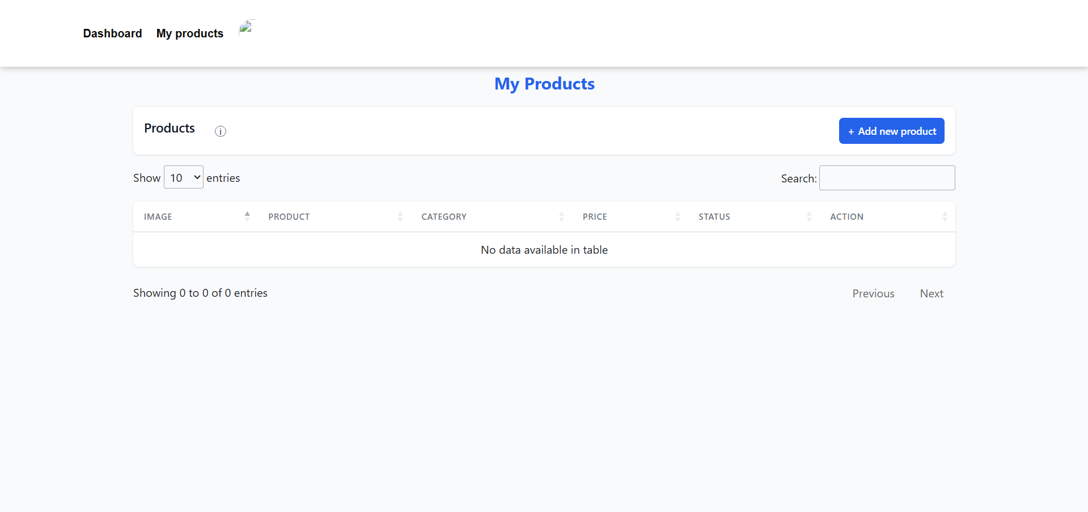

**Fig 10 : User Product Page**

**Weekly Internship Log 1**

**Name of the Student:** Komal Kishna Shrestha **Date: 2080-08-01**

**Project:** Rental Marketplace , Product And Service Management

System

**Week Number: 1**

**Responsibilities:**

Introduction to the company's organizational structure and working culture and familiarization with fellow employees and team members.

Initial project discussion focusing on the Rental Marketplace , Product And Service Management System web application.

Learning about the Laravel and its components.

**Activities:**

Engaged in introductory meetings and orientation with team members

Explored the company's working domains through presentations

Set up the environment by installing necessary tools like Composer, XAMPP, and

visual Study Code

**Observations:**

The company emphasizes a collaborative and innovative working environment. Recognized the significance of the Laravel in building dynamic and efficient web applications.

Realized the importance of a well-structured development environment for seamless coding.

**Plan for Next Week:**

Begin learning the basics of HTML, CSS, and JavaScript.

Continue learning about Laravel.

**Performance Appraisal by Mentor:**

Komal has shown a strong start to his internship by actively participating in orientation sessions and demonstrating a keen interest in learning. His engagement in project discussions and commitment to setting learning goals are commendable..

**Mentors’ Approval**

**Signature:**

**Name: Chhatraman**

**Shrestha**

**Date: 2080-08-01**

**Supervisors’ Verification**

**Signature:**

**Name: Sir Rakesh Thakur**

**Date: 2080-08-01**

**Weekly Internship Log 2**

**Name of the Student:** Komal Kishna Shrestha **Date: 2080-08-8**

**Project:** Rental Marketplace , Product And Service Management

System

**Week Number: 2**

**Responsibilities:**

Learning the basics of Laravel framework and its components

Understanding database configuration and migration in Laravel

Exploring authentication system implementation

Studying Blade templating engine for view rendering

**Activities:**

Completed several Laravel tutorial modules focusing on routing, controllers, and

Created initial database migrations for user and product tables

Implemented basic user authentication using Laravel's built-in authentication system

Experimented with Blade templates to create reusable UI components

**Observations:**

Realized the power of Laravel's Eloquent ORM for database operations.

Noted the efficiency of Laravel's authentication scaffolding for quick implementation.

Recognized the importance of well-structured database relationships for rental

Marketplace System.

Understood the value of Blade templating for creating modular and maintainable views.

**Plan for Next Week:**

Begin implementing the database schema for rental products and categories

Start developing the basic CRUD operations for product management

Create initial routes and controllers for the main application modules

**Performance Appraisal by Mentor:**

Komal has make excellent progress this week , quickly grasping the fundamental of laravel and inplementing the basic authentication features.His attention to detail in database design shows promise for the development of this project.

**Mentors’ Approval**

**Signature:**

**Name: Chhatraman Shrestha**

**Date: 2080-08-08**

**Supervisors’ Verification**

**Signature:**

**Name: Sir Rakesh Thakur**

**Date: 2080-08-08**

**Weekly Internship Log 3**

**Name of the Student:** Komal Kishna Shrestha **Date: 2080-08-16**

**Project:** Rental Marketplace , Product And Service Management

System

**Week Number: 3**

**Responsibilities:**

Setting up the Laravel project structure for the Rental Marketplace platform

Designing comprehensive database schema for rental products and services

Implementing models and their relationships for core system entities

Creating migration files for database structure

**Activities:**

Designed and implemented database tables for products, categories, locations, and

Pricing.

Created Eloquent models with appropriate relationships (one-to-many, many-to-many).

Implemented database seeders for testing with sample data.

Developed initial controllers for product management operations.

**Observations:**

Understood the importance of database normalization for complex data relationships.

Realized how Eloquent relationships simplify data retrieval across different tables.

Noted the significance of consistent naming conventions for database columns and

Relationships.

Recognized the value of database seeders for testing application functionality.

**Plan for Next Week:**

Start implementing user authentication with multiple roles (admin, user).

Start developing Begin developing the administrative dashboard interface.

Create Controller and view for user profile management.

**Performance Appraisal by Mentor:**

Komal has demonstrated string database design skill in this week, creating a well structured schema that accommodates the complex relationships needed for the multi service platform . His adaption to the laravel’s ORM and migration is impressive.

**Mentors’ Approval**

**Signature:**

**Name: Chhatraman Shrestha**

**Date: 2080-08-08**

**Supervisors’ Verification**

**Signature:**

**Name: Sir Rakesh Thakur**

**Date: 2080-08-08**

**Weekly Internship Log 4**

**Name of the Student:** Komal Kishna Shrestha **Date: 2080-08-24**

**Project:** Rental Marketplace , Product And Service Management

System

**Week Number: 4**

**Responsibilities:**

Implementing user authentication with role-based permissions

Developing user profile management functionality

Creating the admin dashboard structure

Beginning the product management module implementation

**Activities:**

Extended Laravel's default authentication with custom user roles and permissions.

Created controllers and views for user profile management (view, edit, update).

Designed and implemented the admin dashboard layout with navigation.

Developed CRUD operations for product category management.

Implemented middleware for protecting admin routes from unauthorized access.

**Observations:**

Recognized the importance of secure authentication for protecting sensitive operations.

Understood the benefits of middleware for route protection and request filtering.

Noted how form validation improves data integrity and user experience.

Realized the value of consistent UI patterns across different administrative functions.

**Plan for Next Week:**

Complete the product management system with full CRUD functionality.

Implement the product filtering system based on multiple parameters.

Begin Developing the user-facing product listing and detail pages.

**Performance Appraisal by Mentor:**

Komal has made a significiant Progress implementing core authentication and admin

Feature . His attention to security details in the authentication system and thoughtful

Approach to the admin interface design shows growing maturity as a developer.

**Mentors’ Approval**

**Signature:**

**Name: Chhatraman Shrestha**

**Date: 2080-08-24**

**Supervisors’ Verification**

**Signature:**

**Name: Sir Rakesh Thakur**

**Date: 2080-08-24**

**Weekly Internship Log 5**

**Name of the Student:** Komal Kishna Shrestha **Date: 2080-09-02**

**Project:** Rental Marketplace , Product And Service Management

System

**Week Number: 5**

**Responsibilities:**

Completing the product management system with full CRUD operations

Implementing the product filtering system by categories, locations, and price

Developing user interfaces for product listing and details

Creating responsive design elements for cross-device compatibility

**Activities:**

Completed full CRUD operations for product management including image uploads.

Implemented advanced filtering functionality using query and Eloquent queries.

Created responsive product grid and list views with filtering options.

Developed detailed product view pages with image galleries and specifications.

Implemented price range filtering using JavaScript and AJAX for dynamic updates.

**Observations:**

Understood the complexity of implementing effective filtering systems with multiple

Parameters.

Recognized the importance of optimized database queries for filtering performance.

Noted how AJAX improves user experience for dynamic content filtering.

Realized the challenges of creating responsive interfaces for varying screen sizes.

**Plan for Next Week:**

Begin implementing the e-ticketing module functionality

Integrate search functionality across all service types

Implement additional service modules into the platform

**Performance Appraisal by Mentor:**

Komal has excelled in implementing the product management and filtering system this week .His solution for the multi-parameter filtering is particularly impressive ,showing both technical skill and user oriented thinking.

**Mentors’ Approval**

**Signature:**

**Name: Chhatraman Shrestha**

**Date: 2080-09-02**

**Supervisors’ Verification**

**Signature:**

**Name: Sir Rakesh Thakur**

**Date: 2080-09-02**

**Weekly Internship Log 6**

**Name of the Student:** Komal Kishna Shrestha **Date: 2080-09-10**

**Project:** Rental Marketplace , Product And Service Management

System

**Week Number: 6**

**Responsibilities:**

Implementing unified search functionality across all service modules

Integrating different service types into a cohesive platform

Conducting comprehensive testing of implemented features

Preparing documentation and deployment preparations

**Activities:**

Implemented system-wide error handling and logging mechanisms

Conducted thorough testing of all implemented features, identifying and fixing bugs

Created user documentation for both admin and end-user interfaces

Prepared deployment scripts and configuration files for production environment

Participated in final review meetings to evaluate project progress

**Observations:**

Realized the challenges of maintaining consistent user experience across service

modules.

Understood the importance of testing for identifying edge cases and bugs

Recognized the value of documentation for future maintenance and user guidance

Noted how proper error handling enhances application reliability and user experience

**Plan for Next Week:**

Complete final system refinements based on feedback

Prepare for project handover and knowledge transfer

Create a presentation summarizing the development process and achievements

**Performance Appraisal by Mentor:**

In this final week, Komal has successfully integrated the various component for the

Rental marketplace system into cohesive system .His implementation of the search

Functionality across different sevice types demonstrates technical proficiency.

**Mentors’ Approval**

**Signature:**

**Name: Chhatraman Shrestha**

**Date: 2080-09-10**

**Supervisors’ Verification**

**Signature:**

**Name: Sir Rakesh Thakur**

**Date: 2080-09-10**